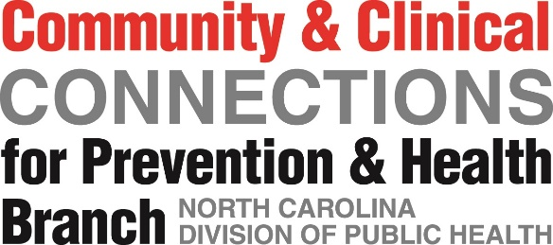

Paul Coverdell National Stroke Program
NC Stroke Systems of Care

SSC Action Plan
Strategy:

Outcome #1:

Outcome #2:

Action Steps (specific activities that assist in accomplishing the goal) | Responsible Party/Partners (individual or agency responsible for action step) | Output  (e.g., # of trainings, partners, etc.) | Timeline (estimated completion date) | Progress (reported monthly to describe progress in action steps)
Enter Action Step |  |  | Date
Enter Action Step
Enter Action Step
Select at minimum one strategy. Within each strategy, address a minimum of two outcomes.

