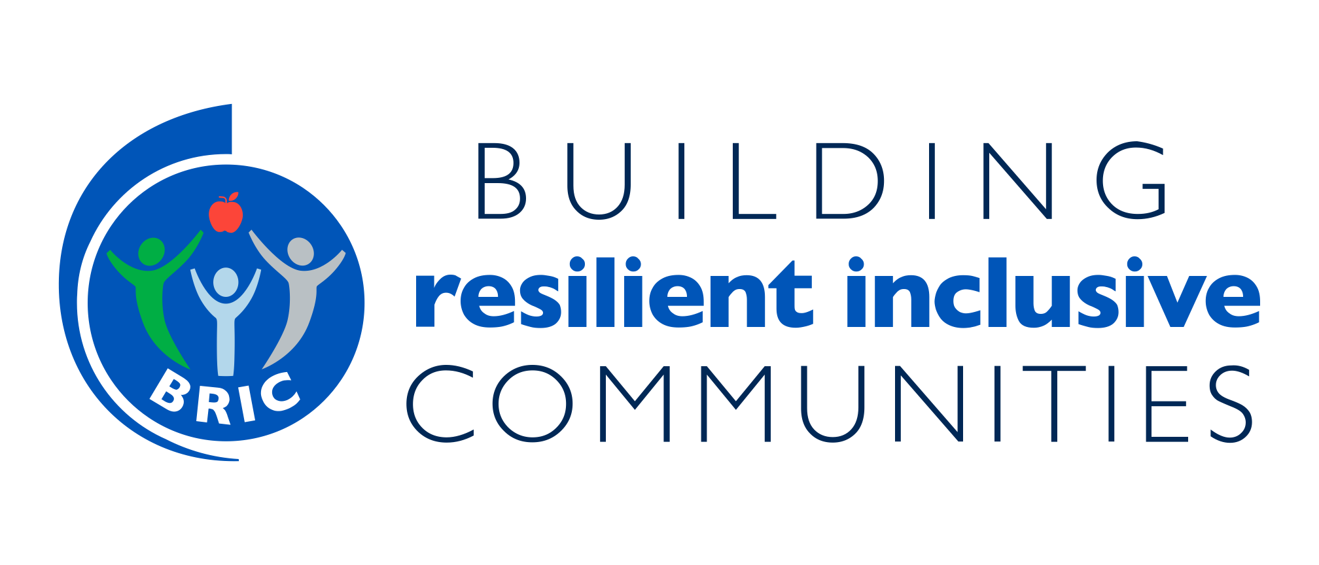

Building Resilient Inclusive Communities (BRIC)
Community Action Planning Template
(CCCPH version 7/1/21)

In collaboration with
NACDD, CDC and NTAP

Building Resilient Inclusive Communities (BRIC)
Community Action Planning Template
Community/Organization Name: Click here to enter

Introduction
Community Action Plans are meant to provide the action steps to make progress toward outcomes selected in collaboration with your state. The plan may be revised over the course of the grant in consultation with the State. Community Action Plans must consider the following key BRIC concepts:

- Resilience – comes from strong interconnected partnerships, authentic community engagement and health equity (adapted from Center for Community Resilience)
- COVID-19 – what gaps were identified in the community as a result of COVID-19? How will you address these gaps in the action steps?
- Health Equity and Inclusion – considers partners that serve populations and/or communities most impacted by COVID-19 and other health inequalities
- Policy, Systems, and Environmental (PSE) Change – the focus of BRIC is on progress towards PSE level changes within each strategy area.

Please complete the BRIC Strategy Area(s) related to your project. You are required to select at least two strategies and at least two outcomes per strategy. All three sections must be completed per strategy area.

Strategy Areas
For any of the three BRIC strategy areas (Nutrition Security, Physical Activity Access, and Social Connectedness) that you are working on, please provide the following information:
- PSE Outcome: provide the specific outcome your community is working towards
- Provide justification and examples on how you will address health equity and community gaps identified during COVID-19.
- Provide action steps with timeline to assist in achieving the outcomes selected.
- For each action step provide
  - Responsible Party
  - Expected Output anticipated annual output - you may have more than one output per action step
  - Additional Comments
  - Actual Output and Progress (to date) - these columns are greyed out and should only be updated as part of quarterly progress for each action step and actual (to date) output.
  - Add new or delete unused rows
- Example action steps in RED font are provided as suggestions only.

Building Resilient Inclusive Communities (BRIC)
Community Action Planning Template
Community/Organization Name: Click here to enter

Strategy Areas
For each strategy area below, State and communities must work toward making policy, systems, and environmental improvements. Action Plans should consider how State and community efforts together can build resilience and address equity and inclusion.

Nutrition Security #1: Improve equitable access to healthy foods through implementing nutrition standards at food banks, pantries and other key food distribution anchor institutions, including new efforts, partnerships, and/or adaptations to implementation as a result of COVID-19.

I. Select at least two nutrition security outcomes you plan to address.
☐ Collaborate with food council/coalition/task force on equitable nutrition security for food banks, pantries, and/or feeding sites during COVID-19
☐ Efforts to increase number of food banks, pantries, or feeding sites in each community selected to adopt nutrition standards due to increase in demand during the COVID-19 pandemic
☐ Efforts to support the increase in the number of people in communities who receive healthier foods distributed by food pantries, food banks, or other feeding sites, taking into effect how demand has changed during COVID-19

II. Please describe for this Strategy Area your approach to addressing health equity and the need to address community gaps identified during COVID-19.

III. Please complete the following Strategy Action Plan Matrix.

Action Steps (to include timeline)  Action Steps are specific activities, benchmarks, or achievements that assist in accomplishing the goal; the timeline is an estimated completion date | Responsible Party/Partners  Agency or individual responsible for achieving the action step. Also include partner(s) if any | Expected Output  Provide an expected output or count for each action step, such as # of trainings, # of partners, etc. | Additional Comments  Added comments or resources useful for achieving the action step | Actual Output  Actual output will be completed during quarterly reporting to help quantify actions achieved | Progress  Progress column(s) will be completed during quarterly reporting to describe progress in planned action steps and how efforts may have pivoted with COVID-19 and to address equity and inclusion
Nutrition Example  Community will collaborate with the local food policy council on training food pantry personnel on the newly revised nutrition standards for adoption by the organization. | Community Nutrition Coordinator | 2 training workshops  10 food pantry personnel trained
Nutrition Example  Community will provide support for storing healthy foods for distribution by purchasing refrigeration equipment. | Community BRIC Lead | 5 refrigerators purchased to support 5 food distribution sites
Action Step 1.1:
By (insert month/year), enter action step here (row will expand)
Action Step 1.2:
By (insert month/year), enter action step here (row will expand)
Action Step 1.3:
By (insert month/year), enter action step here (row will expand)

Building Resilient Inclusive Communities (BRIC)
Community Action Planning Template
Community/Organization Name: Click here to enter

Section 2: Strategy Areas

Physical Activity Access #2: Enhance equitable access to safe places for physical activity and essential travel through plan development and community engagement.

I. Select at least two physical activity access outcomes you plan to address:
☐ Collaborate with task forces/coalitions that support safe, equitable physical activity during COVID-19
☐ Progress to support at least one community improvement plan that includes the potential assessment of local community design as it relates to improving safe and equitable access to physical activity (including number of federal, state or local partners formally engaged) as well as how local demand had changed during COVID-19
☐ Efforts to support at least two verified changes in the characteristics of each selected community that demonstrate walkability or increased safety for those most at risk for COVID-19 illness and death, taking into effect how local demand has changed during COVID-19
☐ Efforts to support at least two alternative commuting facilities, programs or services created or enhanced that support equitable access that can be used by the priority population in each community to safely travel to essential services, including jobs, medical appointments, grocery stores or food pantries, taking into effect how local demand has changed during COVID-19

II. Please describe for this Strategy Area your approach to addressing health equity and the need to address community gaps identified during COVID-19.

III. Please complete the following Strategy Action Plan Matrix.

Action Steps (to include timeline)  Action Steps are specific activities, benchmarks, or achievements that assist in accomplishing the goal; the timeline is an estimated completion date | Responsible Party/Partners  Agency or individual responsible for achieving the action step. Also include partner(s) if any | Expected Output  Provide an expected output or count for each action step, such as # of trainings, # of partners, etc. | Additional Comments  Added comments or resources useful for achieving the action step | Actual Output  Actual output will be completed during quarterly reporting to help quantify actions achieved | Progress  Progress column(s) will be completed during quarterly reporting to describe progress in planned action steps and how efforts may have pivoted with COVID-19 and to address equity and inclusion
Physical Activity Example  Community will coordinate with local transportation organizations (county/MPO) to support safe and equitable travel for essential workers. | Community Transportation Planner | 3 planning meetings held
Physical Activity Example  Community will enhance (develop/leverage) a community plan for community design for safe and equitable access for transportation. | Community Transportation Planner | 1 community plan revised
Action Step 2.1:
By (insert month/year), enter action step here (row will expand)
Action Step 2.2:
By (insert month/year), enter action step here (row will expand)
Action Step 2.3:
By (insert month/year), enter action step here (row will expand)
Action Step 2.4:
By (insert month/year), enter action step here (row will expand)
Building Resilient Inclusive Communities (BRIC)
Community Action Planning Template
Community/Organization Name: Click here to enter

Section 2: Strategy Areas

Social Connectedness #3: Promote opportunities to connect older adults who are socially isolated due to COVID-19 through plan development and community engagement.

I. Select at least two social connectedness outcomes you plan to address:
☐ Collaborate with task forces/coalitions that support equitable social connectedness during COVID-19.
☐ Efforts to implement new or improved community strategies that emphasize and integrate feasible and innovative social connectedness efforts for older adults at higher risk for severe illness from COVID-19; incorporation of existing networks of community health workers should be encouraged.
☐ Efforts to implement at least two new or improved equitable programs for older adults living in high burden communities that offer on-line and in-person educational, social, creative, and physical activities that encourage personal interactions, regular attendance, and community involvement working in collaboration with existing programs (e.g., mental health or Arthritis Programs, AARP, or other)
☐ Efforts to implement at least two new or improved equitable Intergenerational Mentoring Programs in the community to foster healthy, ongoing, supportive relationships between older adults and youth.

II. Please describe for this Strategy Area your approach to addressing health equity and the need to address community gaps identified during COVID-19:

III. Please complete the following Strategy Action Plan Matrix.

Action Steps (to include timeline)  Action Steps are specific activities, benchmarks, or achievements that assist in accomplishing the goal; the timeline is an estimated completion date | Responsible Party/Partners  Agency or individual responsible for achieving the action step. Also include partner(s) if any | Expected Output  Provide an expected output or count for each action step, such as # of trainings, # of partners, etc. | Additional Comments  Added comments or resources useful for achieving the action step | Actual Output  Actual output will be completed during quarterly reporting to help quantify actions achieved | Progress  Progress column(s) will be completed during quarterly reporting to describe progress in planned activities and how efforts may have pivoted with COVID-19 and to address equity and inclusion
Social Connectedness Example  Community will establish (or enhance) a partnership with community organizations serving older adults (e.g., AAA, local AARP chapter, or other senior organization). | Community Lead | 3 new partnership agreements
Social Connectedness Example  Community will collaborate with local organizations that support older adults (e.g., AAA, AARP local chapter, senior centers) to implement intergenerational programs. | Community BRIC lead with partners at local AARP | 2 new programs supporting PA implemented | Planning done that includes social distancing requirements
Action Step 3.1:
By (insert month/year), enter action step here (row will expand)
Action Step 3.2:
By (insert month/year), enter action step here (row will expand)
Action Step 3.3:
By (insert month/year), enter action step here (row will expand)

